Kevin Corbett

Game 414

Design Document

12/06/2016

**FarOut**

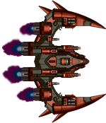

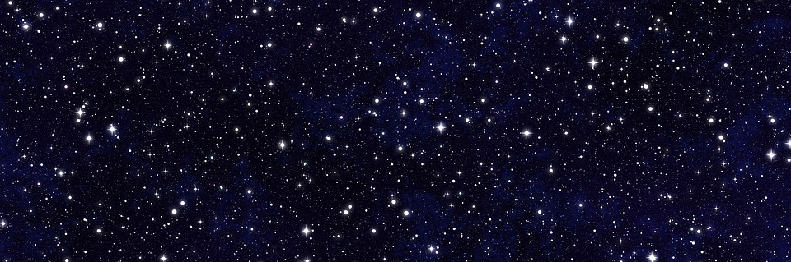

**FarOut**

FarOut is a 2D Sci-Fi ship battle game. With basic RPG elements in combat to the gathering aspects where you can build up your ship, there is a lot to do in FarOut

Being similar to games like FTL and Pokémon, FarOut would appeal to a large audience. The target demographic would have to be teenagers and older. FarOut is gender neutral so it should not appeal more to one gender over another. Looking to release mainly on PC with possible consoles much later, that too will help keep the demographic aimed at older people.

Some of the main selling points would be just how simple yet fun the game can be. One main feature would be how you can salvage a destroyed enemy ship for parts to use in helping build up your ship.

Another major selling point would be the battle system. Being similar to Pokémon, it will be familiar to people, and simple enough to understand. You can have up to 5 weapons of different types at a time to attack with. Each weapon has ammo and a cooldown time, so it encourages use of other weapons, not just your strongest one. Also weapons have different damage types that work better on things such as Shields, Armor, and Hull. You can also have defensive weapons such as anti-missile defense systems or repair drones etc.



**Features:**

* **Single-player battle strategy**
* **Resource gathering system**
* **Meant to be challenging**
* **Random events/situations**
* **Battle system**

To further explain the above features, I will start with the resource gathering system. After destroying a ship, you will have the choice to salvage it for materials currency weapons systems etc. There are market places that you can visit to upgrade your ship, repair it etc. but it is expensive so salvage will be an excellent way to keep an edge up on the enemy. After a ship is destroyed the player can either continue to the next fight, go to the market or salvage the ship and then optionally go to the next fight or go to the market. Salvaging will be chance based depending on the outcome of the battle (was it a close fight? Better loot if so, otherwise maybe just scraps to prevent farming). The only downside to salvaging is there is a chance that you damage your ship even more.

The next major feature would be the random event system. FarOut is meant to be a tough challenging world. Things can go wrong. Your weapons can misfire and damage yourself, or even be destroyed. You can try to salvage a ship and it self-destructs severely damaging your ship.

Mod support is a huge part of the game. Allowing players to craft their own experiences is a major goal in mind building this game. Games like Minecraft are as good and popular as they are mainly due to mods. They can completely change how the whole game works. You will be able to download mods and place them in an easily accessible mods folder where players can drop mods in and load them into their game. You will be able to change textures and such easily with this. Everything else will be handled by the game such as the loading of new items etc.

Instead of just being a left click to win type game, battles will be more time consuming and will require more skill to win. Similar to games like Pokémon, battles will require skill to defeat including special attacks and items that you can use every turn.



**Timeline and Budget:**

I hope to have a basic rough map implemented by mid-October and at the very least basic player controls. By November I aim to have the map, player controls and basic actions implemented such as hopefully destroying and placing blocks. By mid-November I want to have the layered system in place so that you can start digging and building on the z-axis. With the end of November, I should have basic resources and gathering them added for things like metal wood. Next by the beginning of December I want there to be gathering added for things such as fishing farming and such. Lastly by the end of the semester I will have the basic needs system implemented where the player needs to eat drink and sleep.

As the sole developer, there is a ton of work to be done in a short amount of time. The budget can be lower if I am able to get artwork free and open sourced as well as made myself, but my hourly rate will be much higher than if I had been with a team. Say to start 15$ an hour spent working on developing the game would be doable. That includes all time spent researching and working on assets for the game.



**Competitive Analysis:**

Some competition for the game would be Faster Than Light and Pokémon. These are all similar games that I draw ideas from in making this game. FarOut is more similar to FTL than Pokémon, but I detract from all of them a little. FTL is the main inspiration behind my game. I have the turn based battle system from Pokémon where you have attack moves and then items you can use where in FTL is systems subsystems etc.

Starting with player controls, it is all mouse click based, so it would work well on mobile and console. You interact with the menus to make actions by clicking on them, so mobile support would be the most likely next platform to target. The random events system is also fairly similar to FTL. FTL has it where weapons can damage interiors of the ship that will then effect oxygen and systems. With FO, I want it to be a focus on the actual combat, so weapons can malfunction and damage the ship based on their damage, so you want to keep your weapons repaired.

The resource gathering system is very similar to FTL events. For FO I want it to be a necessity. Instead of going to a shop or station to restock and repair after a fight, I want the player to scrap things together to push on through fights. As for mods, as far as I know there are not too many mods if at all for either FTL or Pokémon. Minecraft is my main inspiration for mods, as that is where I really gained traction in my coding skills. There won’t be too much a difference between modding FO as modding is modding, but as with the other games, it will be open for changes by others too.



**DLC:**

As for potential sequels and DLC/Addons, I have no plans for them. If anything, in the future there could be a revamped redone version of the game, but I would much rather support the game I built and released. Too many developers make false promises and never deliver on them, but pull these slimy tricks with DLC and sequels. My philosophy is that everything should be included with the game, and if you are going to charge for DLC, it better be big enough to be considered a game in itself. This includes micro transactions. Micro transactions ruin video games and make others including myself not want to touch the game. They too are a slimy trick to get more money, especially targeting younger kids to get their parents money. I want the customer to get what they see. I will not lock any content behind a paywall, and the furthest I would ever go would be ads with a free version if I am not charging for the game. You will ultimately make more money and respect selling your game for what it is instead of trying to squeeze every penny out of your few users.



World and Story:

The main story behind the game is that with global warming continuing to grow out of control each year, the ice caps have been melting and causing the water levels to rise worldwide. With growing overpopulation, these three factors combined have caused a global crisis. Humanity secretly worked together to invent the warp drive to achieve faster than light travel. 4 fleets were sent out to target candidate star systems, and you are a pilot whose job it is to protect the colonial vessel on its way to its destination. After beginning the final stretch of the journey to the target system, your fleet encountered a distress call that sounded like the crew of one of the other colonial vessels from the other fleets. The difficult decision to go and investigate the distress call was made. Why is the ship so far away from its destination? What could have happened to the ship that caused it to send a distress call? If anyone knew the answers to these questions, they would never have turned around. Our galaxy is inhabited by a malicious AI whose main aspiration is to assimilate the entire galaxy. Where this AI came from we may never know, but they will stop at nothing before destroying all other life as we know it. Here our story follows in the shoes of an unknown sentinel trying to protect the last known remaining Colonial Vessel as it makes its way to its destination as seemingly endless hordes of Cipher ships throw themselves at you. Can you survive long enough to see your fleet to the destination or will your struggle be in vain?



**Characters:**

* **Main Character**:

1. The main character’s gender and name is meant to be unknown.
2. I want there to be a focus on the world rather than the player character.
3. You are a sentinel in the United Earth Cipher Task Force trained in space combat.
4. You were there when the fleet discovered the remains of the other fleet and for first contact between Cipher and Humanity.
5. The MC sprite would be just an unknown spacecraft.

* **Enemy**:

1. Enemies will have different ships, but they will all follow the same general appearance as the Cipher just want to assimilate everyone hence the similarity.
2. They are Cipher AI controlled ships.
3. The only way to truly stop Cipher is to destroy them since they have one and only one goal in mind.
4. All they want is to assimilate the galaxy and now they have discovered the existence of humanity.

As for actual people, you will never really see a person as these ships are huge and the focus is on ship combat over personal dialog etc.



**Levels:**

FarOut is a space battleship combat game. The levels you encounter take place in the style of different fights. Enemies will have varying strengths and weaknesses for you as the player discover and learn to defeat. You must be able to adapt in combat to survive as FarOut is not meant to be an easy game. Between fights you can salvage destroyed ships and take the time to repair/outfit your own for the next fight.

*An example of 2 levels*:

* You start the game in the first encounter.
* This ship is easy to take down, it only has 50 armor and 50 structure
* You will take some damage, but you will be equipped to easily defeat the ship and repair what damage you take while you learn the game.
* After the fight is over you have the option to risk salvaging the ship for ammo items weapons etc. but if you fail your ship will take damage.
* Then when you are ready you begin the next encounter which will feature a much stronger ship that is about equivalent to you in terms of armor and structure.

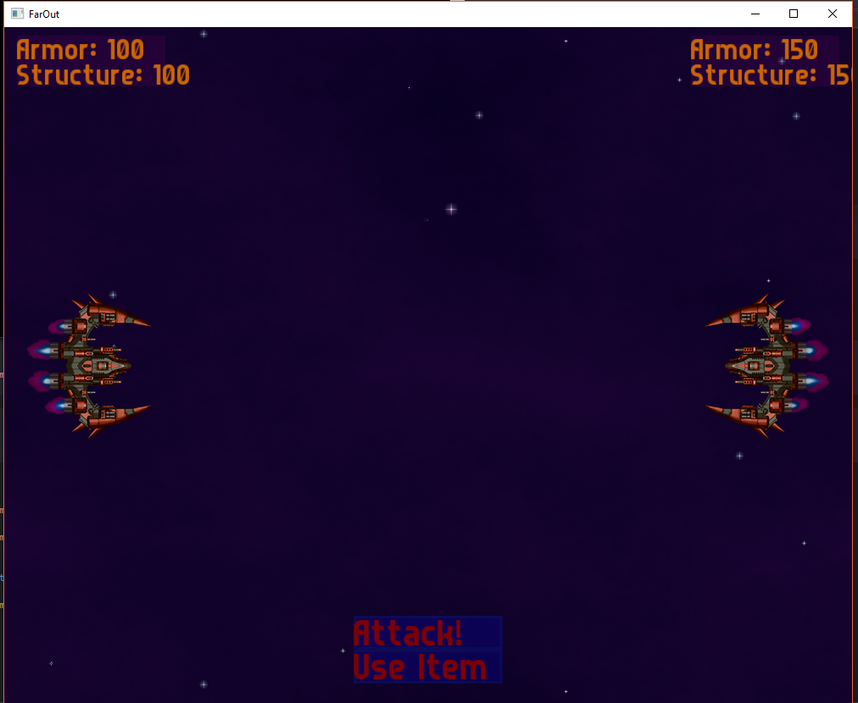

*(an example level)*



**Asset List:**

I will need assets for multiple Ships as well as the backgrounds, fonts, sound effects and all of the GUI elements. Ships such as the player ship or Cipher ships will take up a large portion of the assets. I will have low ambient background music with sound effects for attacking and being attacked. The backgrounds will just be a space background with the two ships overlaid on top. As for the font, I will likely use the same font for most of the assets including the interaction menus. For the UI, everything will be clickable and highlight when hovering over it. That will be very simple to do without having to make individual menu art.

*Some specific examples*:

1. **Player**
   * Ship sprite sheet
   * Ship hover animation
   * Ship thruster animations
   * Ship destruction sprite sheet
   * Ship destruction sound effect
   * Ship attack sound effect
   * Ship damaged sound effect
   * Ship evasion sound effect
2. **Enemy**
   * Ship sprite sheet
   * Ship hover animation
   * Ship thruster animations
   * Ship destruction sprite sheet
   * Ship destruction sound effect
   * Ship attack sound effect
   * Ship damaged sound effect
3. **General**
   * Menu music
   * Game ambient sound
   * Weapon firing
   * Menu interaction sounds
   * UI icons
   * Fonts for UI
   * Main Menu background sprite
   * Game background sprite

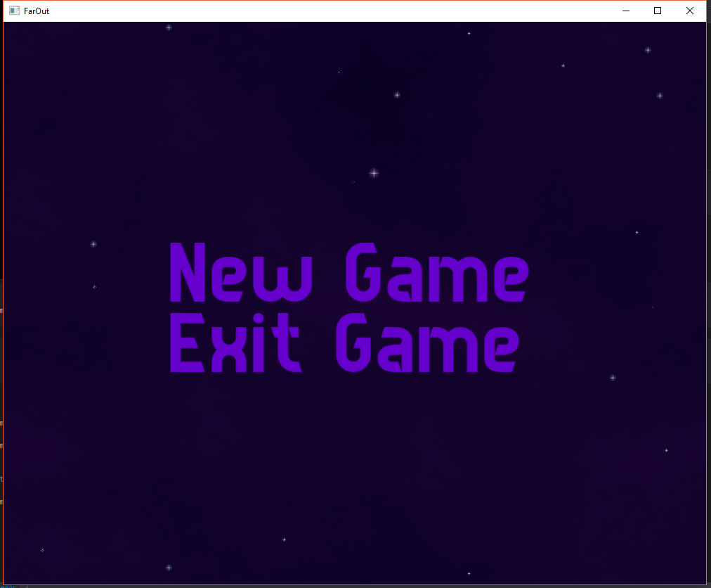

*(Main Menu Example)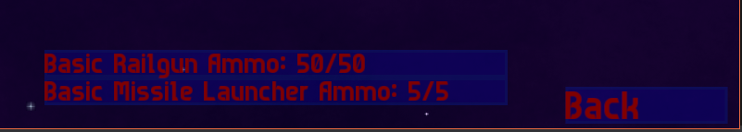*

*(Action Menu Example)*



*(Level/Main Screen Example)*

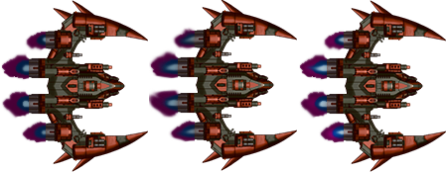

*(Ship Animation/Sprite Sheet Example)*

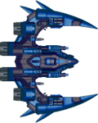

*(One Ship Example)*



*(Another Ship with Engines Example)*